GovSecure AI Chef™
Enterprise AI Governance Recipe Matrix Toolkit
Paid SMB Edition | Client-ready operational toolkit
Who it is for  Small and mid-sized businesses adopting AI without a large governance team. | What it gives you  A practical operating model, templates, sample data, and a maturity path from 24 core recipes to 36.
Design style  Creative-enterprise: polished enough to sell, practical enough to run. | How to use it  Start with intake and ownership. Then register systems, tier risk, map controls, monitor, and review quarterly.

Positioning statement
Turn scattered AI policies into a working system with assigned owners, risk tiers, control expectations, and evidence that leadership can actually review.
Version  v1.1 | Recipes  24 core | Roadmap  36 in v2.0

Visual Table of Contents
This page is the awareness asset: a one-page visual that previews the toolkit structure and included templates.
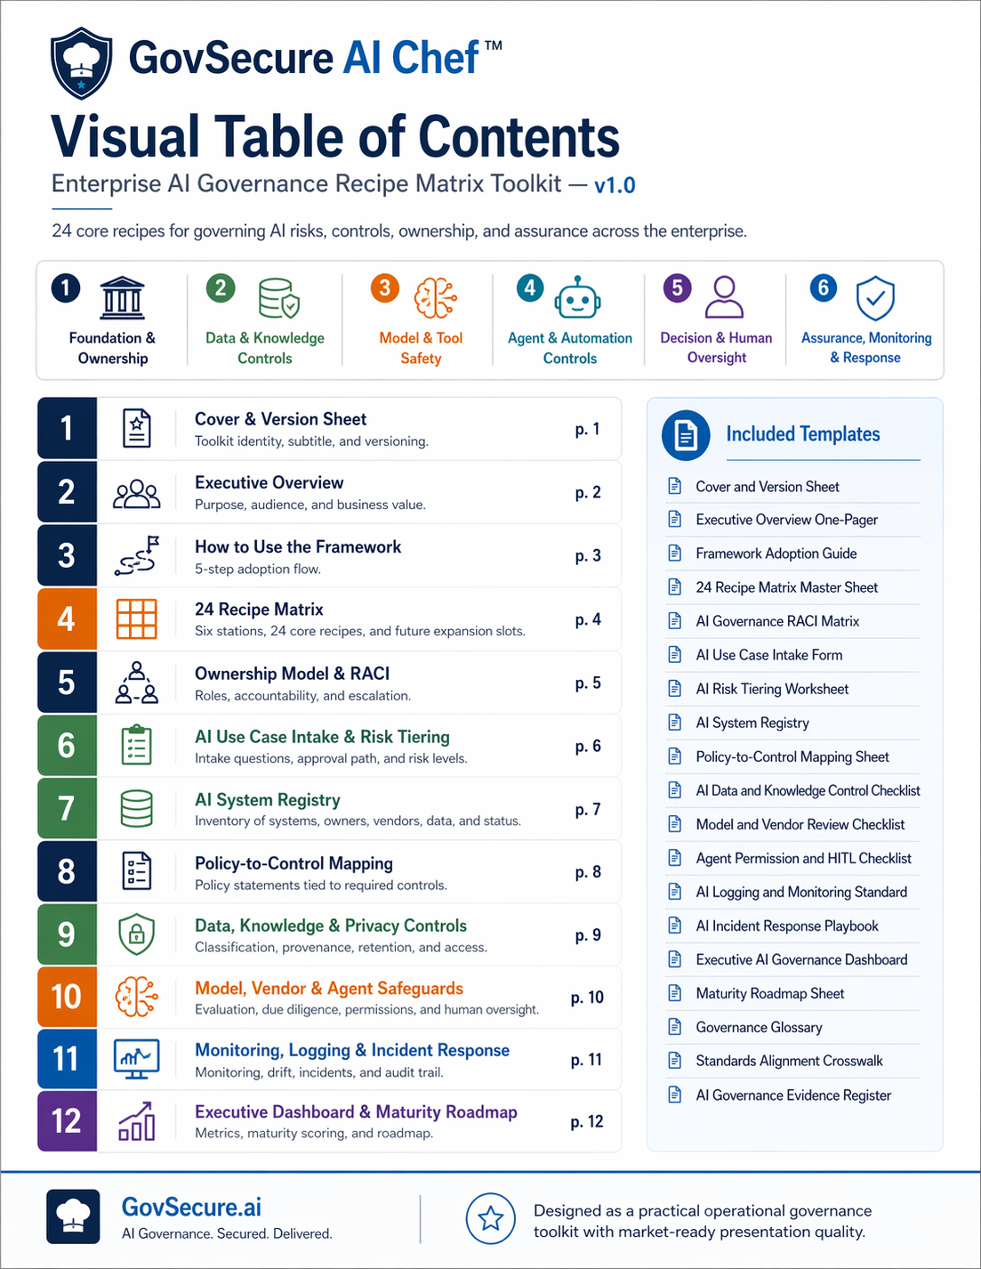

1. Executive Overview
What AI Chef is
GovSecure AI Chef™ is a branded operating model for SMB AI governance. It converts AI risk, control, ownership, and assurance into a recipe system that busy operators can actually use.
Why SMBs need this
- SMBs are adopting AI faster than they are defining ownership, review paths, and acceptable uses.
- Most governance materials are either too abstract for operations or too enterprise-heavy for lean teams.
- Paid buyers want something they can drop into a live program without needing a six-week translation exercise.
Primary buyer profile
SMB owners, operators, and lean technology or compliance leaders who need AI guardrails without building a giant bureaucracy.
What the paid edition adds
- Realistic sample data so teams understand what good looks like.
- Template pages with clear required fields, review cycles, and evidence expectations.
- Appendices that make the toolkit feel implementation-ready rather than decorative.
2. Five-step adoption flow
1 | 2 | 3 | 4 | 5
Identify | Assess | Assign | Control | Review

3. 24 Core Recipe Matrix
Six stations. Four live recipes per station. Two reserved upgrade slots per station for the v2.0 expansion path.
Station | Active recipes | Upgrade path
Foundation & Ownership | • Head Chef Assignment  • Kitchen Rules  • Role Recipe Card  • Approved Menu Only | 2 reserved  advanced slots
Data & Knowledge Controls | • Clean Ingredients  • Source Provenance Check  • Retention & Disposal Recipe  • Knowledge Base Boundaries | 2 reserved  advanced slots
Model & Tool Safety | • Pre-Serve Evaluation  • Secret Sauce Lockdown  • Drift Tasting  • Vendor Pantry Review | 2 reserved  advanced slots
Agent & Automation Controls | • Tool Permission Gate  • Human Before High Impact  • Sandbox Before Service  • Kill Switch on the Counter | 2 reserved  advanced slots
Decision & Human Oversight | • Explain the Dish  • Escalate Ambiguous Orders  • Bias & Fairness Taste Test  • High-Risk Use Case Flag | 2 reserved  advanced slots
Assurance, Monitoring & Response | • Full Kitchen Inventory  • Kitchen Camera Logs  • Burn Response Plan  • Quarterly Recipe Review | 2 reserved  advanced slots

4. Ownership Model and RACI
Sample SMB scenario: HarborCraft Home Goods
A 280-person ecommerce and operations business using Microsoft Copilot, ChatGPT Enterprise, Zendesk AI, and two workflow automations connected to customer support and internal knowledge.
Accountability model
Role | Sample owner | What they own
Executive Sponsor | COO | Approves policy direction, high-risk exceptions, and quarterly review decisions.
AI Governance Lead | Head of Risk & Security | Runs intake, control mapping, registry reviews, and evidence collection.
Business Owner | Support Director / Ops Lead | Owns use-case outcomes, human oversight, and process performance.
IT / Platform Owner | IT Manager | Handles provisioning, connector controls, logging, and technical operations.
Legal / Privacy | External counsel + privacy lead | Reviews data use, notices, and high-impact legal/privacy triggers.
Procurement / Vendor Risk | Finance & Ops Manager | Tracks vendor diligence, contract terms, and dependency issues.
RACI sample across five core tasks
Activity | EX | AG | IT | BU | Notes
Approve high-risk use case | A | R | C | C | Legal/Privacy join as needed
Maintain AI registry | I | A | R | C | Reviewed monthly
Enable logging and connector controls | I | C | A/R | C | Security evidence retained
Quarterly governance review | A | R | C | C | Top risks + exceptions
Pause harmful automation | I | C | A/R | C | Emergency switch with post-review

5. AI Use Case Intake and Risk Tiering
Realistic sample intake
Use case: Customer support co-pilot that drafts responses, summarizes tickets, and suggests refund options to human agents.
Field | Example entry
Business purpose | Reduce average ticket handling time by 20% while keeping a human agent in the loop.
Users | Support agents and team leads.
Data used | Customer emails, order history, product knowledge base, refund policy snippets.
External impact | Customer-facing outputs may be sent after agent approval.
Decision type | Recommendations only; no autonomous refunds.
Regulatory relevance | Privacy review required because customer data and retention are involved.
Human oversight | Mandatory agent approval before send or action.
Proposed risk tier | Tier 2 - Moderate, with Tier 3 controls if refund automation is later enabled.
Risk tier logic
- Tier 1 - Low: internal productivity, low sensitivity, no external decision effect.
- Tier 2 - Moderate: business process support, limited customer or employee impact, strong human review.
- Tier 3 - High: meaningful operational, legal, HR, financial, or customer impact; enhanced review required.
- Tier 4 - Prohibited / Executive review: disallowed use or activity requiring executive decision and documented exception.

6. AI System Registry - realistic examples
System | Biz owner | Tech owner | Vendor | Use case | Tier | Status | Review
ChatGPT Enterprise | Marketing Director | IT Manager | OpenAI | Draft campaigns and summarize research | Tier 2 | Approved | Monthly
Microsoft Copilot | COO | IT Manager | Microsoft | Internal productivity and meeting summaries | Tier 1 | Approved | Quarterly
Zendesk AI Assist | Support Director | Support Systems Lead | Zendesk | Ticket drafting and response suggestions | Tier 2 | Approved | Monthly
Refund Risk Agent (pilot) | Support Director | Automation Engineer | Custom + Azure OpenAI | Suggest refund risk labels before human approval | Tier 3 | Pilot only | Bi-weekly
Vendor Contract Review GPT | Finance & Ops Manager | Security Manager | Anthropic via platform | Draft clause summaries for procurement | Tier 2 | Approved with restrictions | Quarterly
Registry rule of thumb
If a team can name the AI tool but cannot name the owner, review cycle, or permitted use, the registry entry is not complete. That gap is usually where risk starts breeding.

7. Policy-to-Control Mapping
Policy area | Statement | Required control | Evidence
Acceptable use | Teams may use approved AI tools for low and moderate-risk tasks only. | Approved tools list + intake form | Screenshots, approvals, training record
Prohibited use | No autonomous legal, HR, or financial commitments without explicit approval. | Tier 4 gate + exception log | Exception register
Human oversight | Human review is required before customer-facing send or high-impact action. | HITL checkpoints | Workflow screenshot / SOP
Vendor review | No new AI vendor enters production without diligence. | Vendor review checklist | Security + legal review pack
Data handling | Sensitive data must follow classification and approved retention rules. | Connector boundaries + retention config | Config export / policy
Logging | Prompt, action, and decision evidence must be logged where feasible. | Log sources and quarterly review | Sample log + review deck
Incident escalation | AI incidents follow the same containment and review discipline as security incidents. | AI incident playbook | Incident ticket + RCA
Change management | Material changes to models, connectors, or permissions must be reviewed. | Change request workflow | Change ticket

8. Monitoring, Logging, and AI Incident Response
- Monitor drift, misuse, access changes, exceptions, and failed or unusual automated actions.
- Review logs on a defined cadence rather than waiting for the fancy disaster to announce itself.
- Treat harmful outputs, privacy leaks, and connector misuse as operational incidents with owners and evidence.
Recommended incident categories
- Harmful output
- Privacy breach
- Security exposure
- Model or prompt drift
- Unauthorized automation
- Third-party service failure
Reusable page structure preview
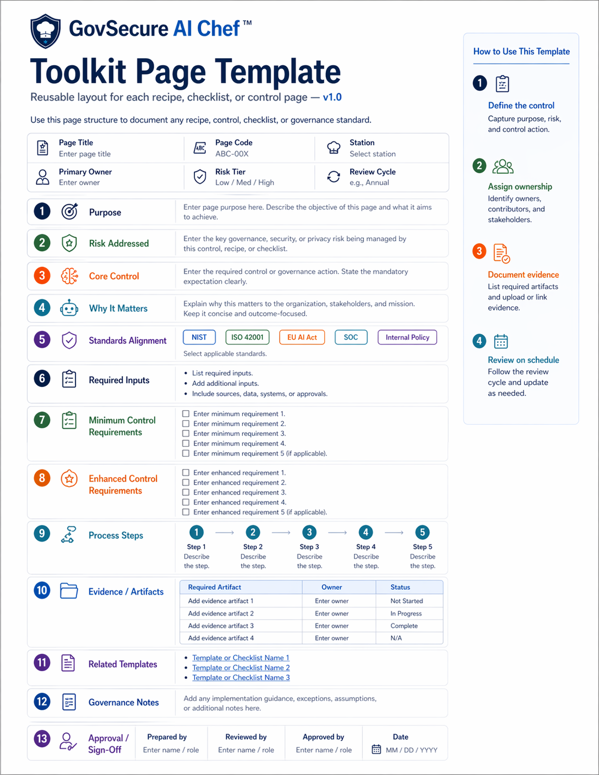

9. Executive Dashboard and Maturity Roadmap
Registered systems  5  1 pilot | % with owners  100%  all named | Quarterly incidents  1  contained | Maturity score  2.6 / 5  managed
Sample dashboard interpretation
- The program is beyond ad hoc because owners, intake, and a registry exist.
- It is not fully operationalized yet because pilot automation remains under enhanced review and evidence collection is still maturing.
- The next jump should focus on logging coverage, formal review notes, and tighter change control.
Level | Label | What it looks like
1 | Foundational | Policy exists but ownership and intake are inconsistent.
2 | Managed | Owners, intake, registry, and baseline controls are in place.
3 | Operationalized | Review cadence, monitoring, and evidence are routine.
4 | Assured | Controls are tested, exceptions are documented, and leadership receives clear reports.
5 | Optimized | Program is measured, improved, and scaled with confidence across business use cases.

Appendix A. Governance Glossary
AI system: Any tool, model, workflow, or agent used to generate outputs, recommendations, or actions.
Agent: An AI-enabled workflow that can take or suggest actions using tools, connectors, or instructions.
High-impact use case: A use case with meaningful financial, legal, HR, customer, or safety impact.
Human oversight: A defined review or approval step performed by an accountable human.
Model drift: A change in model behavior or performance over time that affects output quality or safety.
Shadow AI: AI usage outside approved tools, workflows, or review paths.
Knowledge base: The source material or repository used to ground AI responses.
Prohibited use: A disallowed use case or activity that requires an exception to proceed.
Appendix B. Standards alignment crosswalk
Toolkit area | NIST AI RMF | ISO 42001 | EU AI Act themes
Ownership and governance | NIST Govern | ISO 42001 leadership and planning | EU governance and QMS themes
Risk tiering and use-case review | NIST Map / Manage | ISO risk assessment and controls | EU high-risk logic themes
Data handling and provenance | NIST Map / Measure | ISO data governance | EU data governance themes
Human oversight and decisions | NIST Govern / Manage | ISO operational controls | EU human oversight
Logging and incident response | NIST Manage | ISO monitoring and improvement | EU logging, robustness, cybersecurity
Appendix C. Evidence register
Artifact | Refresh cycle | Owner | Done when
AI policy | Annual or when materially changed | AI Governance Lead | Current version approved
Approved tools list | Monthly | IT / Governance | Current list published
Use-case intake records | Per use case | AI Governance Lead | All active use cases logged
Risk tiering worksheets | Per use case | Business Owner + Governance | Tier rationale documented
System registry | Monthly | IT / Governance | Review date current
Vendor review records | Before production + annual | Procurement / Security | Renewals tracked
Monitoring review notes | Monthly / quarterly | IT / Security | Review notes retained
Incident reports and RCA | As needed | Security / Ops | Closed with lessons learned

